**1. ReactJS-HOL**

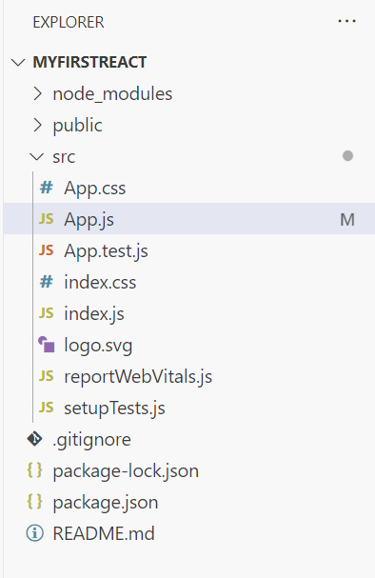

**App.js**  
  
import logo from './logo.svg';

import './App.css';

function App() {

  return (

    <div className="App">

      <h1>Welcome to the first session of React</h1>

    </div>

  );

}

export default App;

